**DAILY ONLINE ACTIVITIES SUMMARY**

|  |  |  |  |  |  |  |  |  |
| --- | --- | --- | --- | --- | --- | --- | --- | --- |
| **Date:** | **16/06/2020** | | | | | **Name:** | **Shwetha** | |
| **Sem & Sec** | **8th B** | | | | | **USN:** | **4AL16CS101** | |
| **Online Test Summary** | | | | | | | | |
| **Subject** | | **BDA** | | | | | | |
| **Max. Marks** | | **30** | | **Score** | | | **26** | |
| **Certification Course Summary** | | | | | | | | |
| **Course** | **Artificial intelligence in python** | | | | | | | |
| **Certificate Provider** | | | **Great learning** | | **Duration** | | | **7hr** |
| **Coding Challenges** | | | | | | | | |
| **Problem Statement:**  **Given a string input Count all lower case, upper case, digits, and special symbols.** | | | | | | | | |
| **Status: Solved**  **Solution link: https://github.com/alvas-education-foundation/Shwetha-** | | | | | | | | |
| **Uploaded the report in Github** | | | | | **Yes** | | | |
| **If yes Repository name** | | | | | **Shwetha-** | | | |
| **Uploaded the report in slack** | | | | | **Yes** | | | |

Online test details:

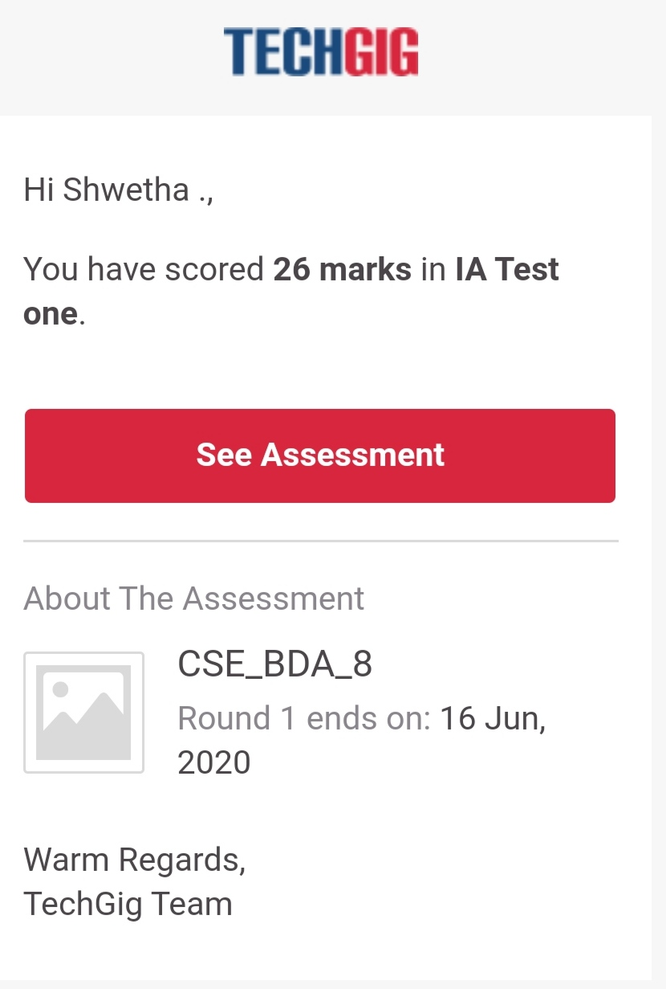

Certification Course Details:

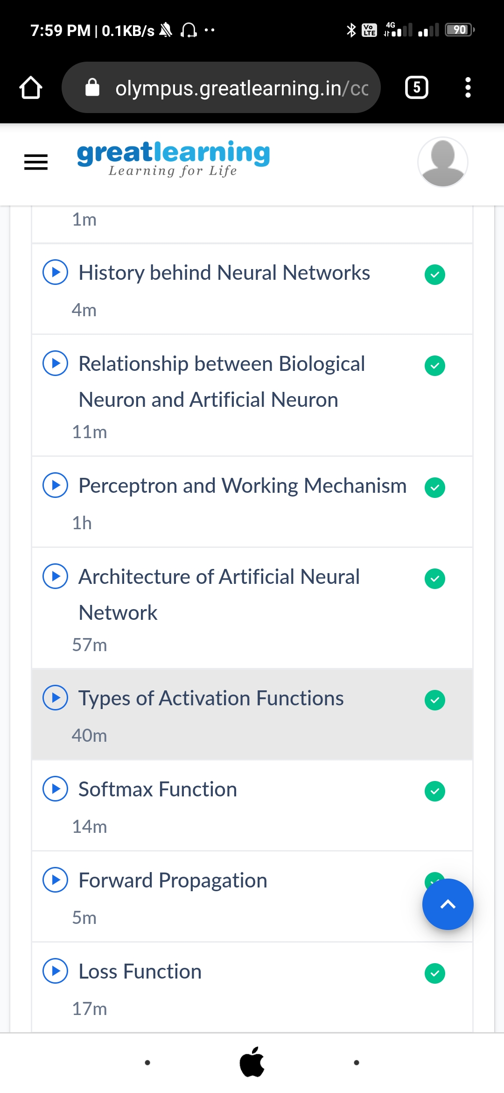

*Coding Challenges Details:*

def findDigitsCharsSymbols(inputString):

words = inputString.split()

CharCount = 0

digitCount = 0

symbolCount = 0

for char in inputString:

if char.islower() or char.isupper():

charCount+=1

elif char.isnumeric():

digitCount+=1

else:

symbolCount+=1

print("Chars = ", charCount, "Digits = ", digitCount, "Symbol = ", symbolCount)

inputString = "P@#yn2" print("total counts of chars, digits,and symbols")

print(findDigitsCharsSymbols(inputString))